Risk Assessment of GTSC Grantees

Beginning in federal fiscal year 2016, GTSC is required to annually assess each grantee’s risk of noncompliance with Federal statutes, regulations, and the terms and conditions of the grant. This is required by Federal Regulations in the Federal Register, Section 1300.4(c)(3), and the CFR, Subpart D Section 200.331(6)(b). See page 10 of this document for reference to these regulations. The goal of the risk assessment is to determine an organization's capacity to manage and/or receive federal grant funds. Information may also be used to plan monitoring activities and/or identify support needed to strengthen a grantee’s management of its program.

A risk assessment is defined as a systematic process of evaluating the potential risks that may be involved in a projected activity or undertaking. This risk assessment process is applied to GTSC’s grant applicants and includes both a programmatic and fiscal evaluation as follows.

Risk Assessment

Step 1: Identify the risk factors for each grantee—the objective of risk identification is the early and continuous identification of events that, if they occur, may have negative impacts on the project's ability to achieve its goals. Examples of risk factors include a new project director and/or grantee, poor performance on a prior grant, or a single audit finding.
Step 2: Analyze past performance by the grantee—grants awarded in prior years should be reviewed to determine whether grant performance goals were met, required progress reports were filed, timely claims were submitted, and information documented in monitoring reports were favorable.
Step 3: Plan for future performance by the grantee—determine if the grantee is at risk for not achieving project goals and/or not complying with grant conditions based on the pre-determined risk factors and analysis of past performance.
Step 4: Monitor and review grantee performance—medium and high-risk of nonperformance on a project must be mitigated by reviewing and monitoring grantee performance if the grant is indeed awarded. Grantees selected for monitoring must be documented and assigned to a highway safety representative. Monitoring of grantees categorized as medium or high-risk must be completed by the end of the grant year.
Step 5: Document findings in a risk assessment spreadsheet. The GTSC staff member assigned to perform risk assessments must document findings of risk identified in steps 1-4 in an electronic file of annual risk assessments located at: \\argo\GTSC\GTSC Risk Assessment. If a grantee falls into the medium or high-risk category and would not otherwise be monitored, document risk findings in the Fiscal Manager Comments section of the Reviewer’s Comments page under the Review section for the associated grant(s) in eGrants.

Programmatic Risk Assessment

Each grant is reviewed to determine if necessary, requirements are met, it is a fundable area, and the application is complete. Assigned reviewers then rate predetermined criteria in eGrants including the project scope, reasonableness of budget, and timeliness of reports/payment requests. Successful scores between 60 and 100 are considered in the risk assessment. A CPS review score sheet appears below.

Review Score Sheet:

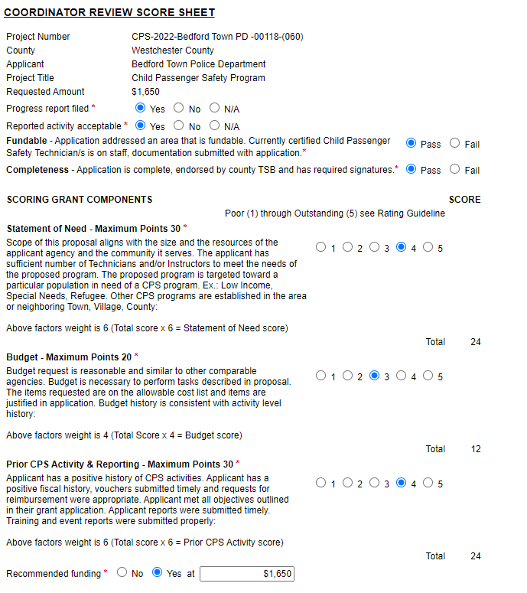

Comments are made on the Reviewer Comment Sheet highlighting relevant elements of the grant and a recommendation to fund or not to fund along with the amount recommended, if applicable. A Reviewer Comment Sheet appears below.

Reviewer Comment Sheet:

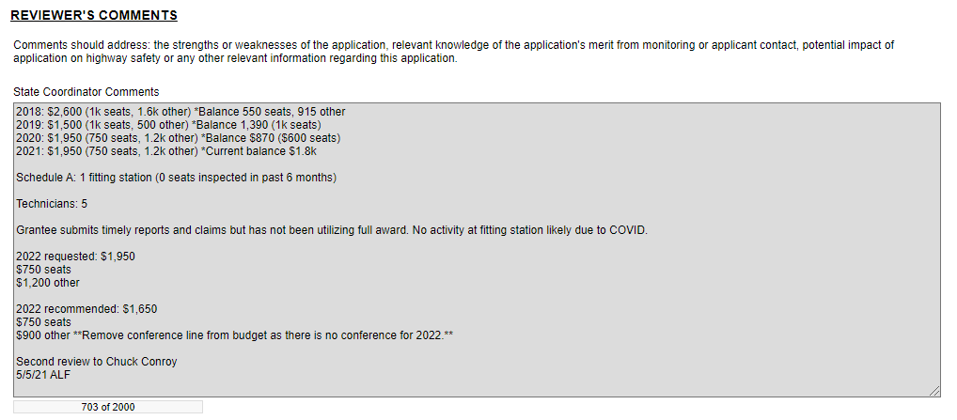

Fiscal Risk Assessment

In addition to a programmatic risk assessment, grantees are subject to a fiscal evaluation as well. Fiscal measures used to assess grantees include:
- Results and compliance with the Federal Single Audit requirement—the Single Audit, also known as the OMB A-133 audit, is an organization-wide audit or examination of an entity that receives $750,000 or more of Federal grant funds. Usually performed annually, the Single Audit’s objective is to provide assurance to the US federal government as to the management and use of such funds by recipients such as states, cities, universities, and non-profit organizations. The audit is typically performed by an independent certified public accountant (CPA) and encompasses both financial and compliance components. The Single Audits must be submitted to the Federal Audit Clearinghouse along with a data collection form, Form SF-SAC. The Federal Audit Clearinghouse is reviewed quarterly to verify grantee compliance with this requirement and to confirm no audit findings were cited for grantees receiving NHTSA funds.
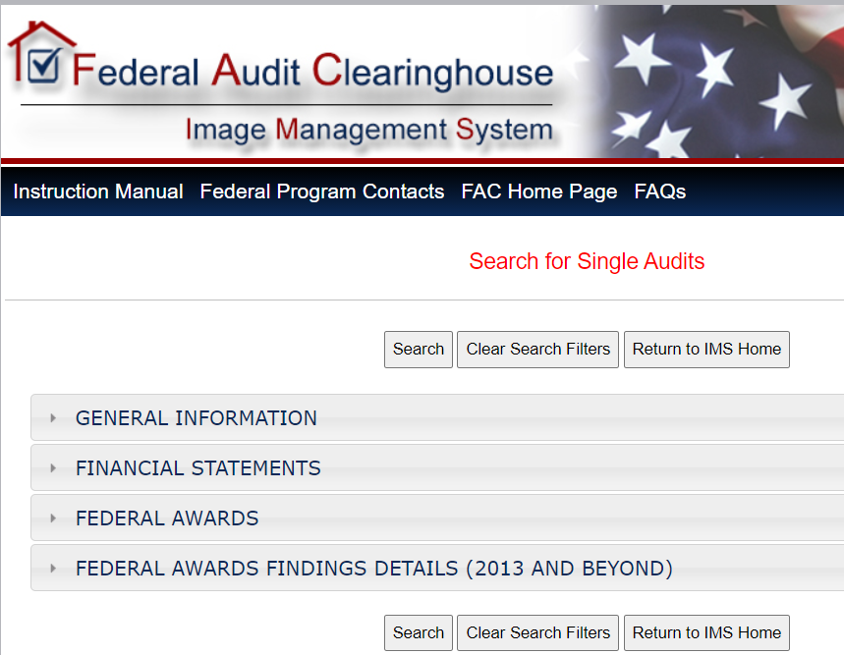

- Prequalification of Not-For-Profit organizations—New York State has instituted key reform initiatives to the grant contract process which require that not-for-profits register in the NYS Grants Gateway and complete the Vendor Prequalification process. This process was designed to streamline the contract process and improve compliance with State and Federal legal and audit requirements. Proposals received from not-for-profit applicants that have not registered and are not prequalified in the Grants Gateway on the proposal due date cannot be evaluated. Such proposals are disqualified from further consideration.

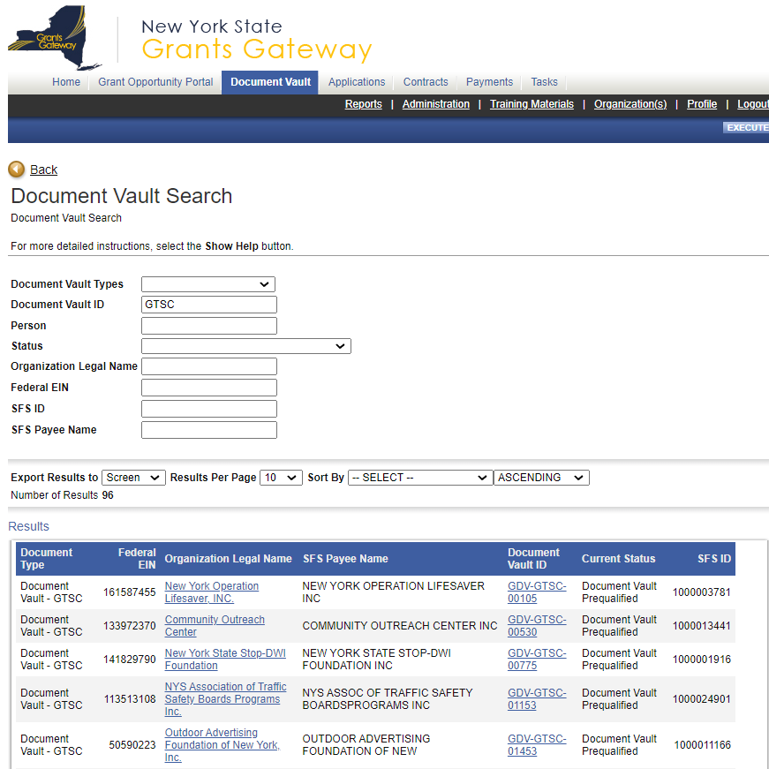

Grants Gateway Document Vault:

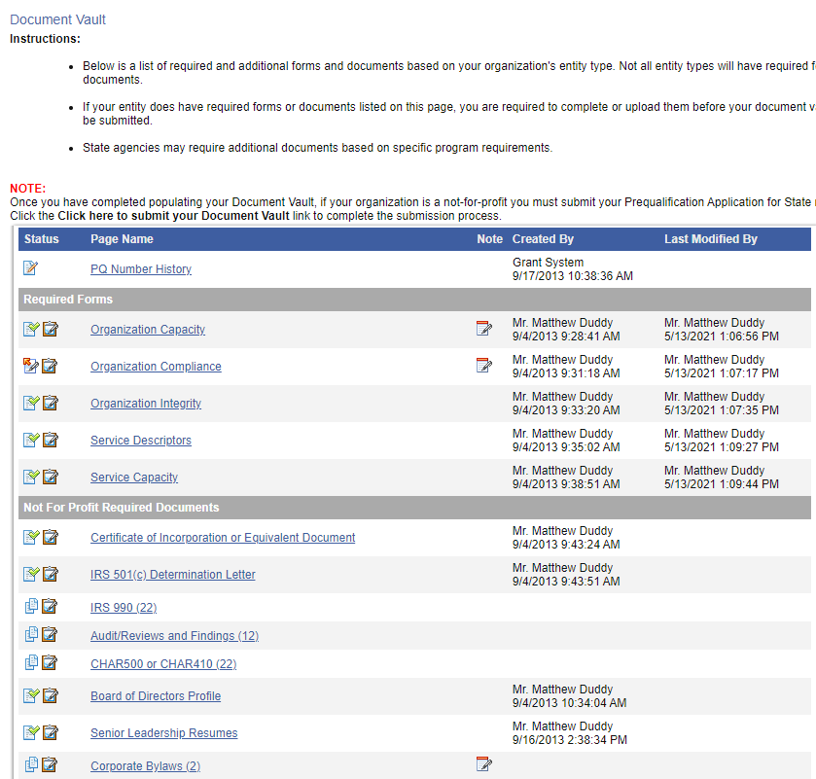

- Vendor Responsibility Questionnaire—Not-For-Profit (NFP) organizations receiving GTSC grants valued at $100,000 or more are required by the Office of the State Comptroller to certify annually as to their organizational integrity in the VendRep system. Additionally, NFP grantees with grants valued at $50,000 or more are evaluated by GTSC using many resources. These resources include: the federal System for Award Management (SAM), multiple lists of debarred entities, and an advanced Google search. A screenshot of the VendRep system appears below.

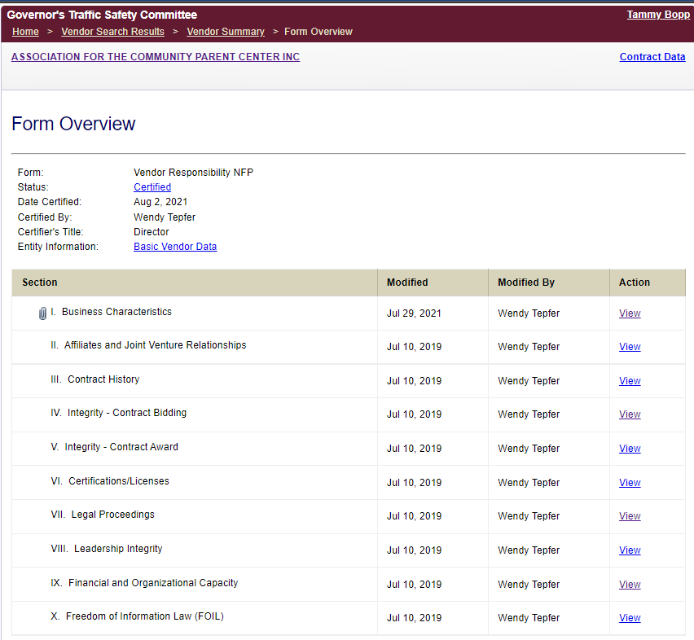

Grantees are evaluated for risk based on the following categories and scoring method:
- Programmatic Review Score: (Relative Weight-15%)
Score | Risk Points
90 - 100 | 0
80 - 89 | 1
70 - 79 | 2
60 - 69 | 3

- Approved Grant Amount: (Relative Weight-25%)
Approved Amount | Risk Points
$1 - $9,999 | 0
$10,000 - $24,999 | 1
$25,000 - $49,999 | 2
$50,000 - $249,999 | 3
$250,000 - $499,999 | 4
$500,000+ | 5

- New Project Director: (Relative Weight-15%)
New PD? | Risk Points
No | 0
Yes | 3

- Single Audit History: (Relative Weight-45%)
Single Audit Filed in Previous Year | Risk Points
Yes, no finding | 0
Yes, finding related to highway safety funds open | 9
Yes, finding related to highway safety funds closed (points counted for two years following a finding) | 3
Yes, finding unrelated to highway safety (effective FFY 2018) | 2
No, unable to determine if required | 2
No, single audit required | 5
FYE Last Audit Filed | Varied

Total Risk:
Total Score | Risk Assessed | Monitoring Guidelines
0 - 8 | Low | Progress report, performance, liquidation, equipment review
9 - 14 | Medium | Low risk elements + formal monitoring + individual review of single audit
15 - 20 | High | Medium risk elements + second follow-up with grantee

Grantees in the medium or high-risk categories must be monitored prior to the end of the grant year (September 30) so that the GTSC can determine if federal grant funds and project deliverables are being properly managed. Additionally, if single audit findings are indicated for the grantee, a GTSC fiscal manager must be invited to go to the monitoring so the single audit finding(s) can be addressed. The rep should also request that someone familiar with the financial or single audit for the entity be in attendance.
The GTSC reserves the right to reevaluate and/or amend a grantee’s assessment of risk at any time. Additional factors may also be used to determine risk or whether a grantee is monitored, and the appropriate method used. For instance, a grantee in the “Low” category, may be monitored based on GTSC‘s specific knowledge of actions or characteristics of an organization or employee(s) of that organization.

Federal Regulations on Risk Assessment

§1300.4 State Highway Safety Agency—authority and functions.
(c) Functions. Each State Highway Safety Agency shall—
(3) Conduct a risk assessment of subrecipients and monitor subrecipients based on risk, as provided in 2 CFR 200.331;

e-CFR Subpart D—Post Federal Award Requirements

Section 200.331(6)(b)
All pass-through entities must:
(b) Evaluate each subrecipient's risk of noncompliance with Federal statutes, regulations, and the terms and conditions of the subaward for purposes of determining the appropriate subrecipient monitoring described in paragraphs (d) and (e) of this section, which may include consideration of such factors as:
(1) The subrecipient's prior experience with the same or similar subawards;
(2) The results of previous audits including whether the subrecipient receives a Single Audit in accordance with Subpart F—Audit Requirements of this part, and the extent to which the same or similar subaward has been audited as a major program;
(3) Whether the subrecipient has new personnel or new or substantially changed systems; and
(4) The extent and results of Federal awarding agency monitoring (e.g., if the subrecipient also receives Federal awards directly from a Federal awarding agency).

How to Conduct the Annual Risk Assessment
After all grants have a determination as to grant funding, the annual Risk Assessment must be completed. Export a list of grants from eGrants using report “Grant Awards Annual for Publication.” Save the file and rename the worksheet tab “Risk Assessment.” Delete any grants that are cancelled, denied or withdrawn. For any blank/incorrect cells in the Federal ID (FEIN) column, this number can usually be obtained from the Grants Gateway or, sometimes, from the Payee ID field in eGrants. Update the organization page in eGrants with the correct FEIN.
- Insert column titled Rep Assigned in column C.
- Delete columns titled City, State, Zip, Alpha, Synopsis and Status.
- Move columns Federal ID, Vendor ID, DUNS Number and Unique Entity ID to columns D – G.
- Add columns Score, Project Director, New PD?, Single Audit Required?, FYE Last Audit Filed, Date Single Audit Filed, Reportable Condition/Significant Deficiency or Material Weakness, Risk: Score, Risk: Budget, Risk: PD, Risk: Audit, Total Risk, Risk Level and Notes after the last column in the report.
- Sort the spreadsheet by Grant Number.
Run the “Recommended Funding Amounts” report to obtain the total grant score.
Sign into eGrants as an administrator or fiscal manager to access Report Builder report “New Project Directors.” Prior to running the report, update the Data Filter “TemplateSubCode” to reflect the grant year for which you are completing the Risk Assessment. Export the report to excel. Delete grants with a status of denied, withdrawn or cancelled. We only determine risk for those grantees who are awarded a grant.
Sort the spreadsheet by grant number. There will be columns titled Project Director and New PD? for each grant type. Cells that say TRUE indicate a new project director. Complete a VLOOKUP formula to populate the Project Director and New PD? fields on the Risk Assessment dependent on grant type. The row number will be specific to the first grant of that type. For example, in the chart below, row 154 is where the first HS1 grant appeared. Copy the formula down until you hit the last row for that grant type. Because the grants are sorted by grant number in the Risk Assessment and New Project Directors worksheets, the formula logic will work if executed properly. Double-check some yeses and nos for each grant type to ensure the formula works as expected.
Grant Type | Formula for Project Director | Formula for New PD?
CPS | =VLOOKUP($B2,New_Project_Directors!$C:E,3,FALSE) | =IF(VLOOKUP($B2,New_Project_Directors!$C:F,4,FALSE)=TRUE,"Yes","No")
HS1 | =VLOOKUP($B154,New_Project_Directors!$C:G,5,FALSE) | =IF(VLOOKUP($B154,New_Project_Directors!$C:H,6,FALSE)=TRUE,"Yes","No")
PTS | =VLOOKUP($B268,New_Project_Directors!$C:I,7,FALSE) | =IF(VLOOKUP($B268,New_Project_Directors!$C:J,8,FALSE)=TRUE,"Yes","No")

The federal government requires a single audit when the grantee receives $750,000 or more in federal funds. Although our limited resources do not allow us to capture all federal funding for all grantees, we know the single audit is a requirement when the GTSC provides funding at or above the threshold. A formula is entered in the Single Audit Required? column to calculate the total amount of awards. Formula: =IF((SUMIF(D:D,D2,I:I)>=750000),"YES","NO/Unknown") is entered in the second row where column D is the FEIN and column I is the awarded amount.
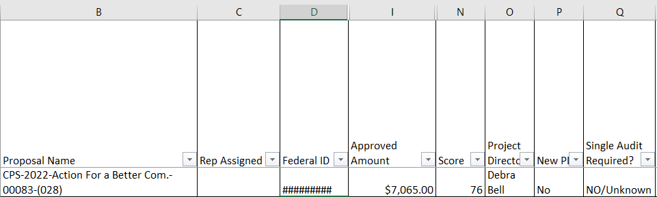

To determine “Date Single Audit Last Completed,” search for and download single audits at the Federal Audit Clearinghouse: https://harvester.census.gov/facdissem/Main.aspx.
Enter the following information in the search:
FAC Release Date – From Date is 10/01/YYYY from the year prior. Pick a recent date for the To Date.
Auditee State – Check New York
Click Search.

When the search results appear, click on Download Summary Report.

Click on the Excel file and move the Search Summary, General Info and Findings worksheet tabs into the Risk Assessment file.
On the General Info tab, find the EIN and move it to Column A.

In the FYE Last Audit Filed in column R of the Risk Assessment tab, enter formula =VLOOKUP(TEXT($D2,"000000000"),'GENERAL INFO'!$A:E,5,FALSE) where Column D is the EIN in the Risk Assessment tab and columns A and E are the EIN and Fiscal Year End Date in the General Info tab.
In the Date Single Audit Filed in column S of the Risk Assessment tab, enter formula =VLOOKUP(TEXT($D2,"000000000"),'GENERAL INFO'!$A:Y,25,FALSE) where Column D is the EIN in the Risk Assessment tab and columns A and Y are the EIN and AUDITEEDATESIGNED in the General Info tab.

In the Reportable Condition/Significant Deficiency or Material Weakness? In column T of the Risk Assessment tab, enter formula =IF(OR(VLOOKUP(TEXT($D2,"000000000"),'GENERAL INFO'!A:AY,51,FALSE)="Y",(VLOOKUP(TEXT($D2,"000000000"),'GENERAL INFO'!A:AZ,52,FALSE)="Y")),"Yes","No") where Column D is the EIN in the Risk Assessment tab and columns A, AY and AZ are the EIN, Reportable Condition/Significant Deficiency and Material Weakness columns in the General Info tab.
Copy the formulas down to the last row in the spreadsheet. Copy and Paste Values in the three columns so the formula disappears and only the values remain. Replace #N/A with blanks.

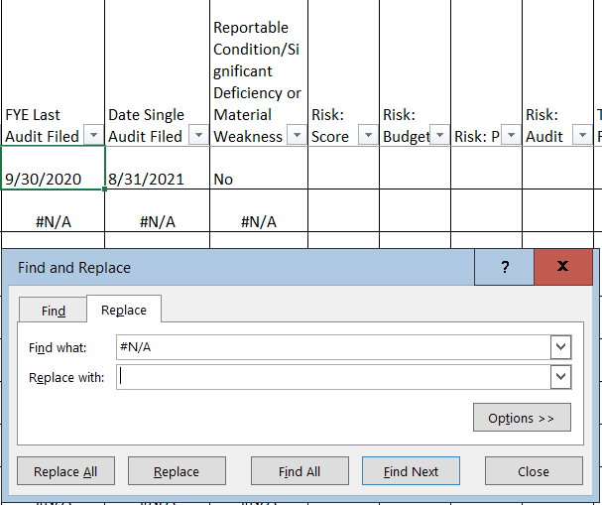

The next steps are to score the risk of the grantee based on the reviewers’ grant scores, the awarded amount, whether there is a new project director and multiple elements of the single audit.
The score generated from the programmatic review on each grant is considered in the risk assessment because it accounts for the past performance of the grantee, whether the project is fundable, how well the problem id and/or statement of need is written, the reasonableness of the proposed solution and soundness of the evaluation plan.
To determine risk based on a grant’s score, enter the formula: =IF((N2)<=59,"",IF(AND((N2)>59,(N2)<=69),3,IF(AND((N2)>69,(N2)<=79),2,IF(AND((N2)>79,(N2)<=89),1,0)))) in row 2 under Risk: Score where column N is the grant score. Copy the formula down to the last row where data exists. The result should be a number between 0 and 3 for each grant.
To determine risk based on a grant’s budget, enter the formula:
=IF((I2)<=9999,0,IF(AND((I2)>9999,(I2)<=24999),1,IF(AND((I2)>24999,(I2)<=49999),2,IF(AND((I2)>49999,(I2)<=249999),3,IF(AND((I2)>249999,(I2)<=499999),4,IF(AND((I2)>500000),5,""))))))
in row 2 under Risk: Budget where column I is the awarded amount. Copy the formula down to the last row where data exists. The result should be a number between 0 and 5 for each grant.
To determine risk based on new project directors, enter the formula: =IF(P2="Yes",3,0) in row 2 under Risk: PD where column P is the indicator for new project directors. Copy the formula down to the last row where data exists. The result should be a number, either 0 or 3 for each grant.
To determine risk based on the single audit:
- Filter the FYE Last Audit Filed column to view dates within the current and last year. For example, if you are completing the risk assessment in 2021, filter this column to view dates of 1/1/2020 and later.
- Filter the Reportable Condition/Significant Deficiency or Material Weakness column to view the Nos.
- Enter a 0 in the Risk: Audit column for the filtered grants. Clear all filters.
Next:
- Filter the Date Single Audit Filed column to view all blanks.
- Filter the Single Audit Required column to view all No/Unknowns. Enter a 2 in the Risk: Audit column for the filtered grants. Clear all filters.

Next:
- Filter the FYE Last Audit Filed column to view dates of two calendar years and older from the date you are completing the risk assessment. For example, if you are completing the risk assessment in 2021, filter this column to view dates of 12/31/2019 and prior.
- Filter the Reportable Condition/Significant Deficiency or Material Weakness column to view the Nos.
- Enter a 2 in the Risk: Audit column for the filtered grants. Clear all filters.
Next:
- Filter the FYE Last Audit Filed column to view dates of two calendar years from the date you are completing the risk assessment. For example, if you are completing the risk assessment in 2019, filter this column to view dates of 12/1 - 12/31/2017.
- Filter the Reportable Condition/Significant Deficiency or Material Weakness column to view the Yes’s.
- Enter a 3 in the Risk: Audit column for the filtered grants. Clear all filters.

Next:
- Filter the Risk: Audit column to view all blanks. Determine the score for each grant based on each grant’s specific circumstance surrounding the single audit and the scoring methodology. This may require you to contact the city/county/town/village to obtain a recent audit, and/or determine if a finding was related to highway safety. Clear all filters.
To determine total risk, enter the formula: =SUM(U2:X2) where columns U – X are each category’s risk score (grant score, budget score, project director score and audit score.) Copy the formula down to the last row where data exists.

To determine each grant’s risk level, enter the formula: =IF((Y2)<=8,"Low",IF(AND((Y2)>8,(Y2)<=14),"Medium",IF(AND((Y2)>14,(Y2)<=20),"High")))
in row 2 under Risk Level where column Y is the total risk score. Copy the formula down to the last row where data exists. The result should be a risk level of Low, Medium or High.
Scores should be verified for all grants in the medium or high-risk categories. All those remaining in the medium or high-risk categories must be shared with program staff to target for monitoring as applicable during the grant year.

